Diagrams
1. High-Level System Architecture Diagrams
These show overall components, integrations (e.g., with PACS), and data flows.
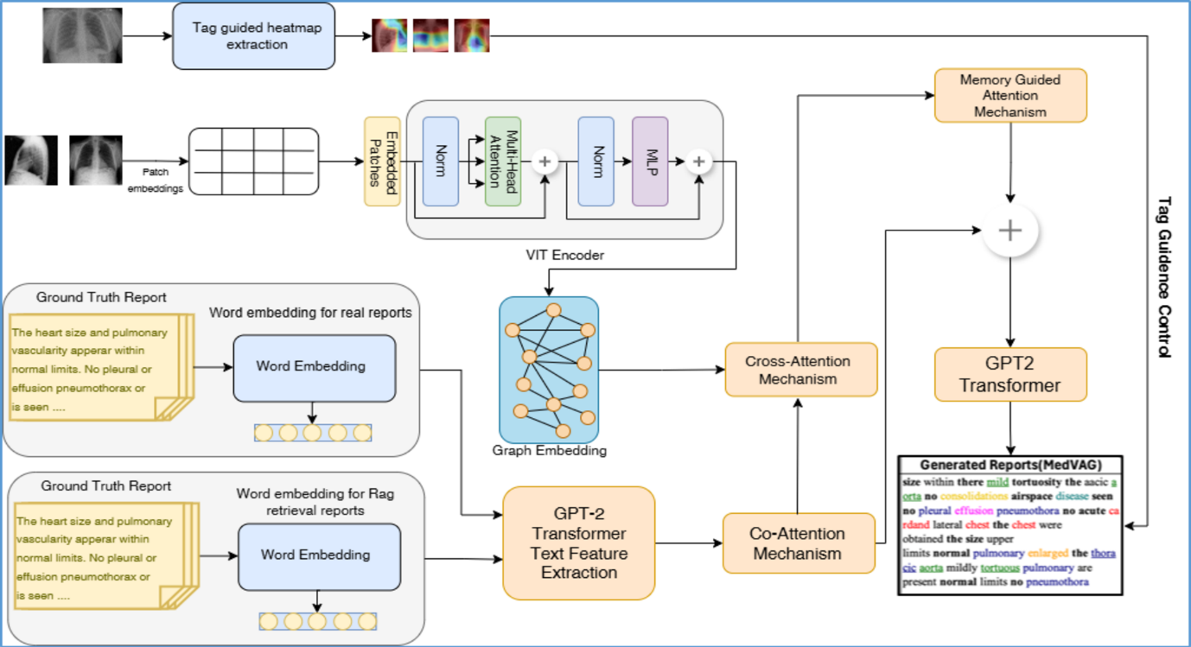
Figure 1: Vision attention-driven Language framework for medical report
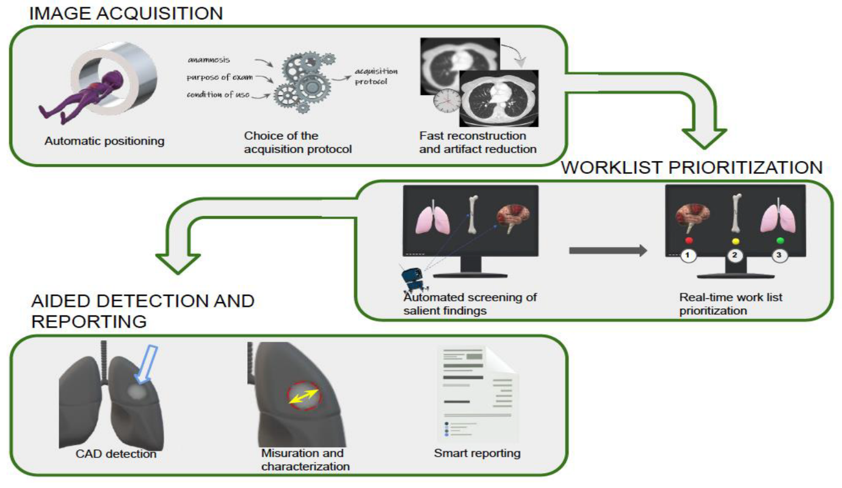
Figure 2: Artificial Intelligence in Emergency Radiology: Where Are We Going?

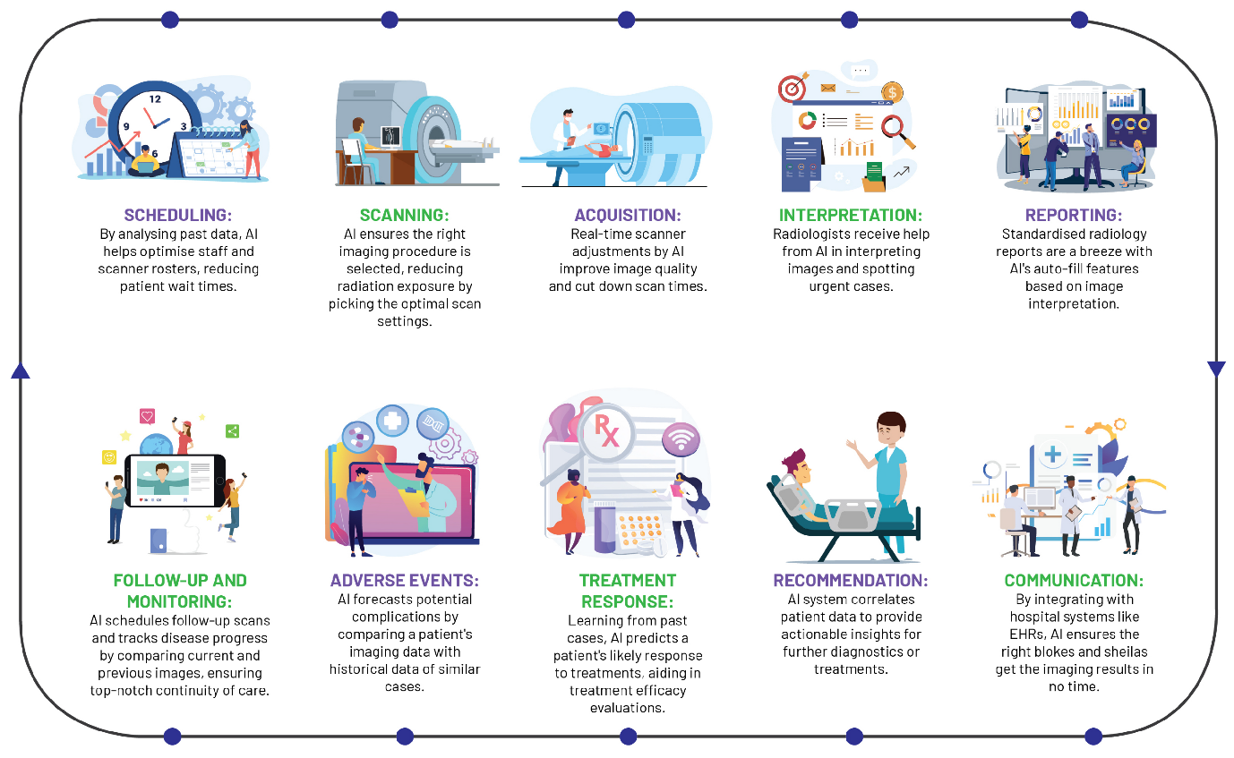
Figure 3: Redefining Radiology: A Review of Artificial Intelligence

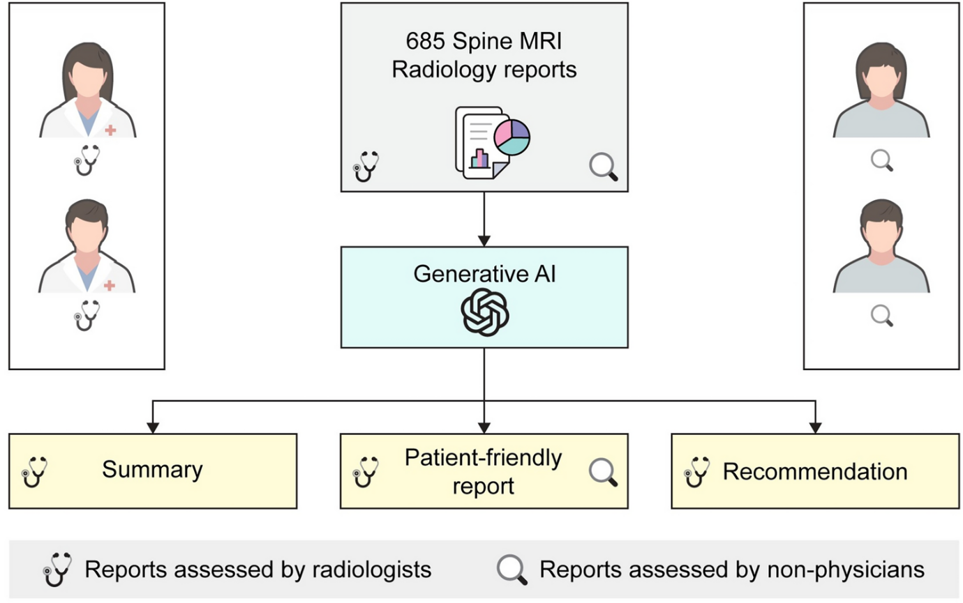
Figure 4: Patient-centered radiology reports with generative artificial

2. Detailed Pipeline Flowcharts
Focus on sequential steps: ingestion → anonymisation → AI analysis → drafting → review.
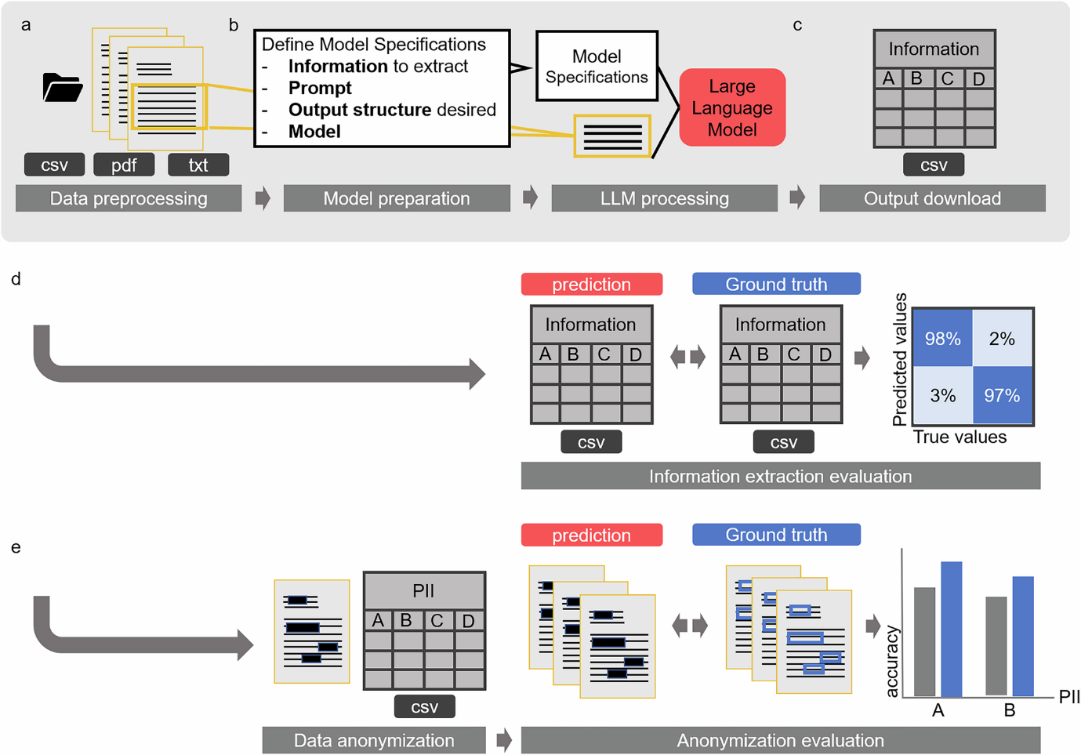
Figure 5: A software pipeline for medical information
3. Vision Transformer (ViT) Specific Architecture
Detail the model used in your AI Analysis Engine.
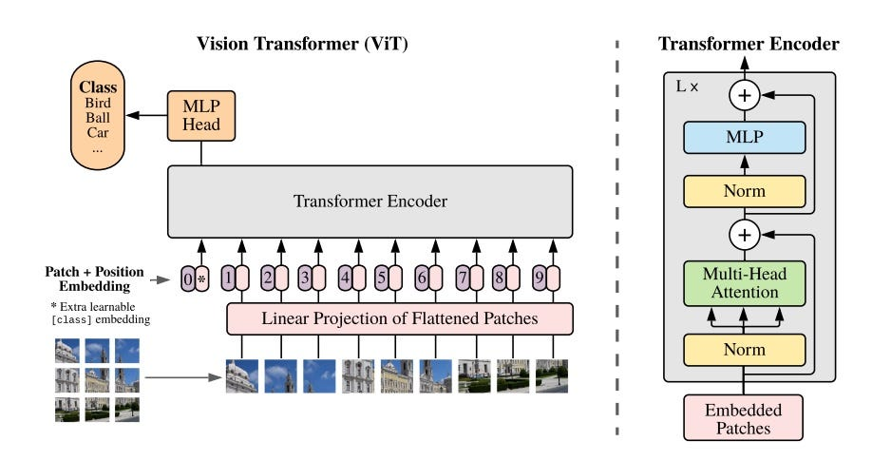
Figure 6: Vision Transformer for classification on medical images
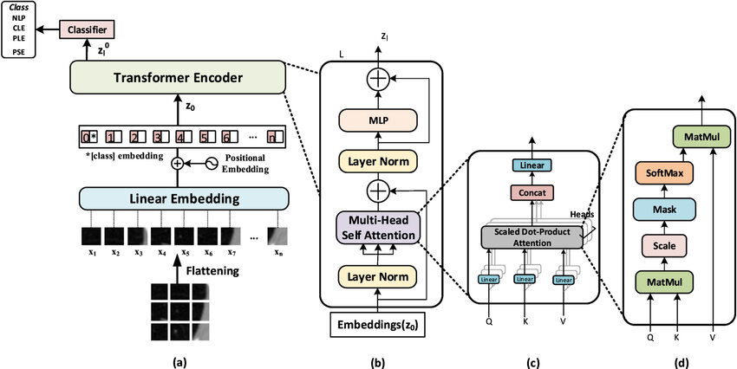
Figure 7: The vision transformer architecture
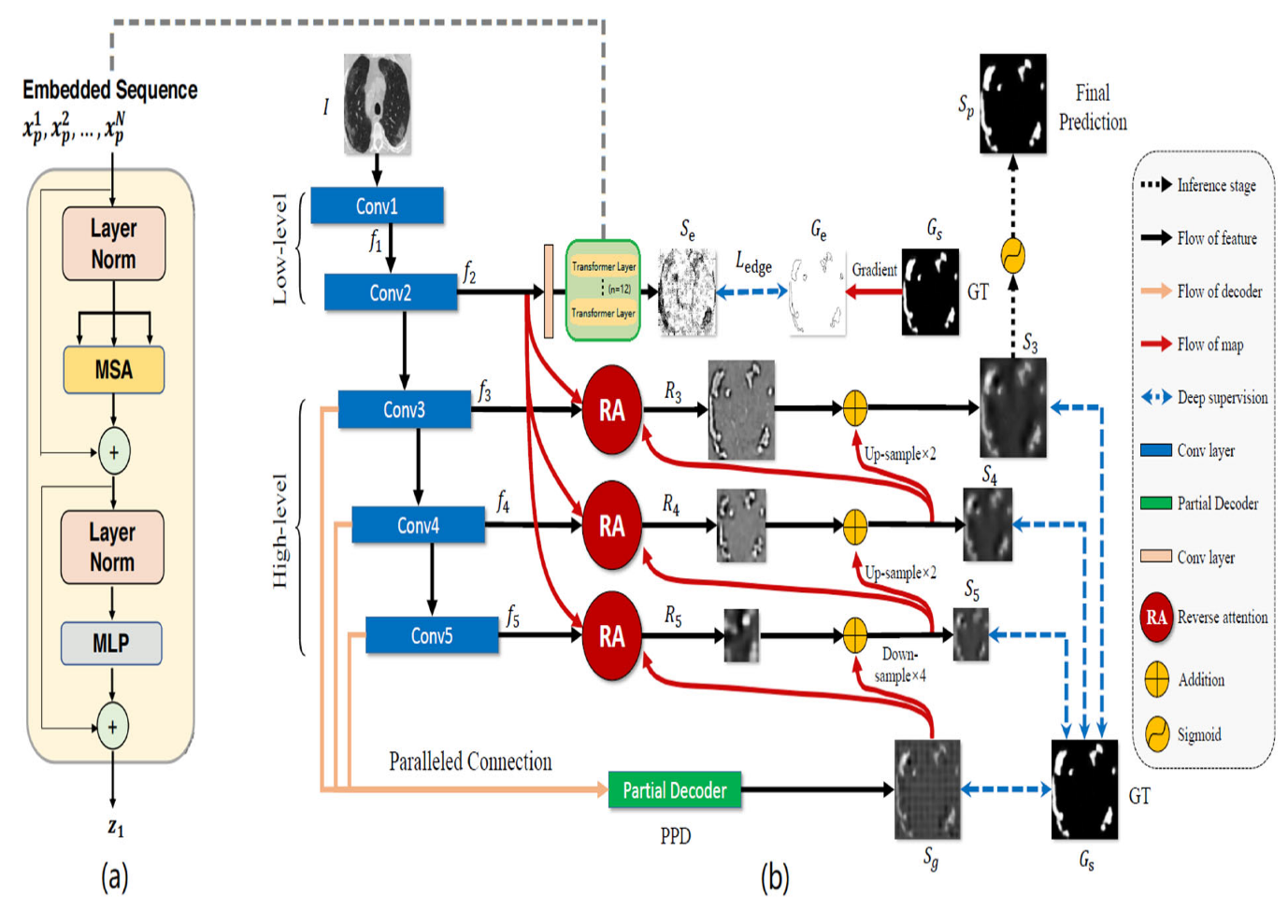
Figure 8: Automatic Medical Image Segmentation with Vision Transformer

4. Swimlane Flowcharts (Emphasizing Human-in-the-Loop)
These separate system vs. clinician roles, highlighting mandatory review.

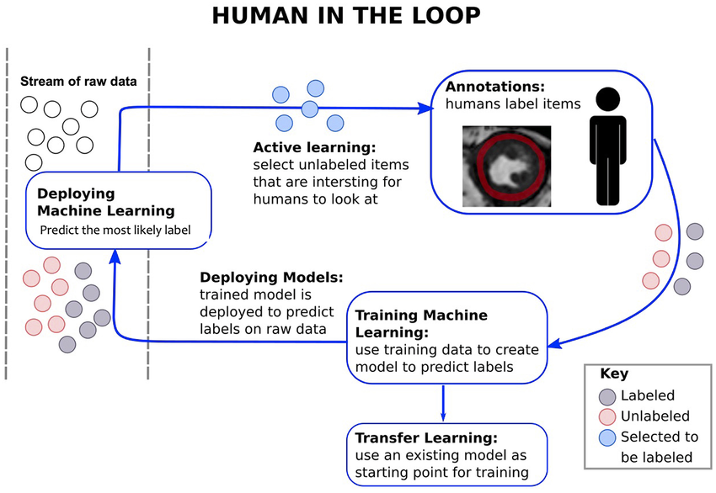
Figure 9: Diagram illustrates the implementation of an artificial
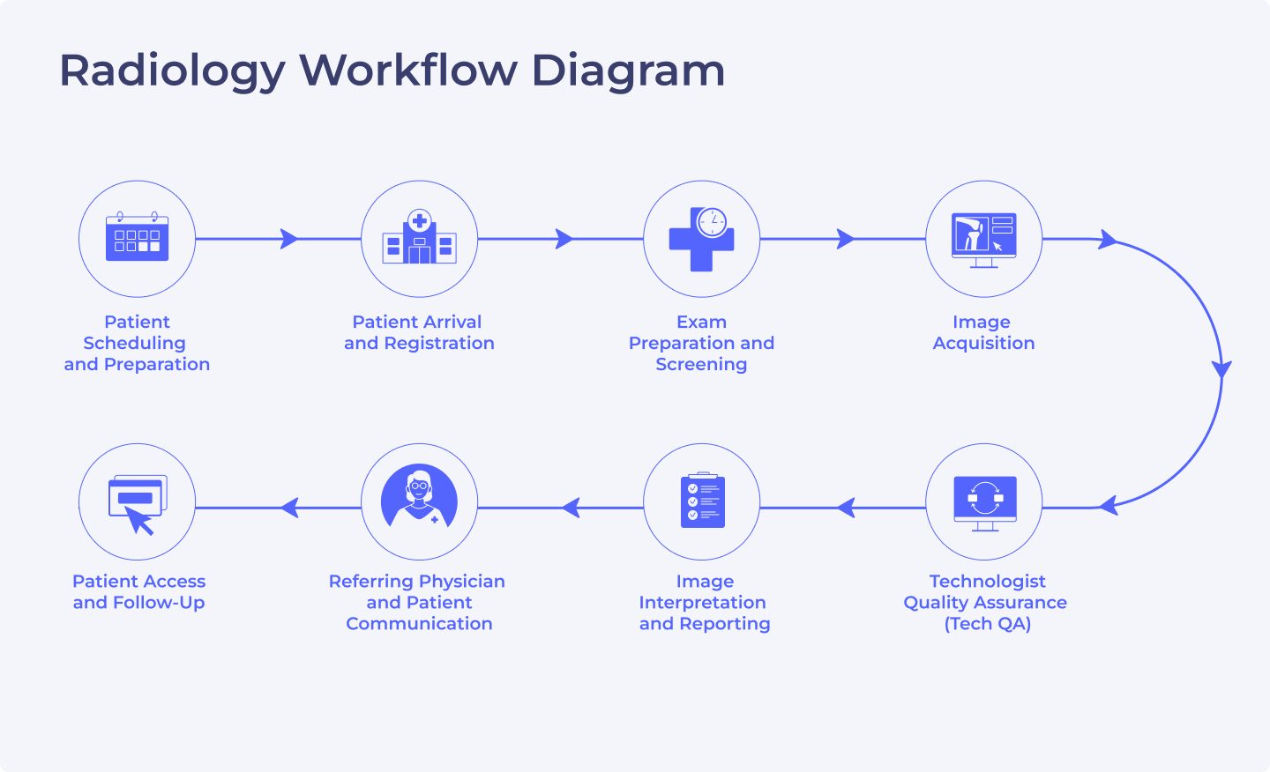

5. Deployment/Compliance Architecture
Show security, data governance (GDPR/MHRA).
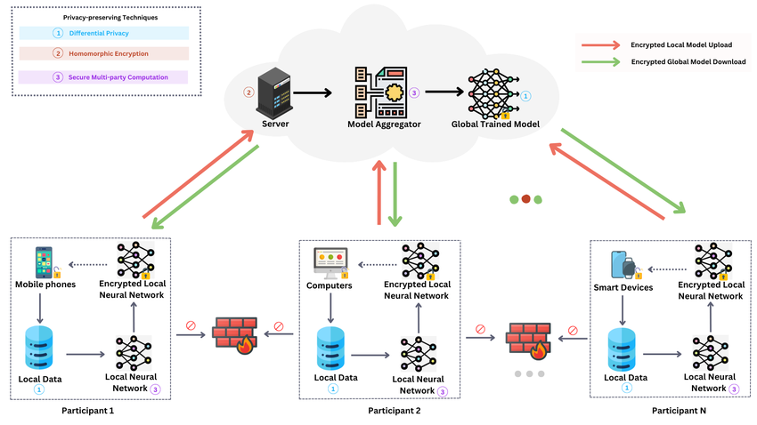
Figure 10: An Architecture diagram of GDPR-Compliant DFL-based Framework

